A

PROJECT REPORT ON

REMOTE HEALTH MONITORING SYSTEM WITH ANALYTICS DASHBOARD

Prepared by,
Madiraju.Sirisha
Asst. Prof., ECE
NMREC, Hyderabad.

CONTENTS

1 |  |  | INTRODUCTION
 |  |  | 1.1 Overview
 |  |  | 1.2 Purpose
2 |  |  | LITERATURE SURVEY
 |  |  | 2.1 Existing problem
 |  |  | 2.2 Proposed solution
3 |  |  | THEORETICAL ANALYSIS
 |  |  | 3.1 Block diagram
 |  |  | 3.2 Hardware / Software designing
4 |  |  | EXPERIMENTAL INVESTIGATIONS
5 |  |  | FLOWCHART
6 |  |  | RESULT
7 |  |  | ADVANTAGES & DISADVANTAGES
8 |  |  | APPLICATIONS
9 |  |  | CONCLUSION
10 |  |  | FUTURE SCOPE |  | `
11 |  |  | BIBILOGRAPHY
 |  |  | APPENDIX
 |  |  | A. Source code

1. INTRODUCTION

1.1 OVERVIEW:

The pandemic effect taught us to realize that many of the things has to be performed remotely. Health is a very important thing for humans. So, remote health monitoring systems plays a vital role in these situations. In this project, a web application through which the health status of the person is assessed and give him the predictions. This prediction helps him to take care of himself, further first aid medication can be suggested to him before approaching a doctor. This is done here using Machine Learning algorithm the health status and Internet of Things. Machine Learning algorithm gives the prediction of ill health and Internet of Things senses the health parameters which are required by Machine Learning algorithm to predict the patient’s health status.

1.2 PURPOSE:

The main purpose of this project is to make the medication handy at all the times to the people from rural areas also. With the application built in this project, people can easily know their health status and the basic precautions to be taken. This makes the percentage of ill health people less. When the patient know his health condition, he will take the best care of himself and will intake nutrition food. Then gets recover easily.

2. LITERATURE SURVEY

2.1 EXISTING PROBLEM :
In the present scenario health is a major issue which has to be given a great attention. It has been a challenging task to the people to go to the doctor and get the treatment. If they are sick in the odd times and at the odd places, the first aid medication is to be given later they can be taken to the doctor. To give the first aid medication, some knowledge of the medicines and the health condition of the patient is required. Without that basic information no one can move forward. There have been so many deaths due to lack of this basic knowledge. When everyone gets educated with this, then so many patients can be treated and sometimes they may even get recovered without going to the doctor also.

2.2 PROPOSED SOLUTION :
This proposed system develops an IoT device which can sense the temperature, diastolic, systolic and pulse values of the person and uploads them in to IBM IoT platform. In the cloud the data will be sent to a Machine learning algorithm to predict his health status and a message is sent to the person alerting him about his health condition. The illness and its severity is predicted by the machine learning algorithm. A dashboard is built to visualize all the health parameters and the health status.

3. THEORETICAL ANALYSIS
3.1 BLOCK DIAGRAM :
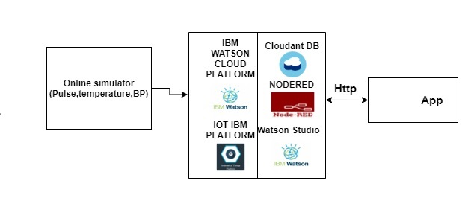

3.2 SOFTWARE DESIGN:
Steps to create IoT device, parameters and upload data to cloudant.
Step 1: Goto dashboard of ibm cloud – select resources – IoT platform – Launch
Step 2: Create device – give device type and device name
Step 3: Copy the credentials of the device (type, name, API key, Authentication token) and paste in a note pad for further use)
Step 4: Open the simulator and write the code
{
"Age": random(0, 100),
"Temperature": random(0, 200),
"Diastolic": random(0, 200),
"Systolic": random(0, 200),
"Pulse": random(0, 200)
}
Step 5: Create a no SQL data base in the cloudant and give a name.
The IBM IoT cloud platform is used to design an IoT device with online simulations. The simulation parameters used are Age, Temperature, Systolic, Diastolic and Pulse. These values are taken randomly through device simulator. These are uploaded into the IBM cloudant database.
Steps to create Machine Learning instance and training
Step 1: Goto resources – Create watson studio instance – launch it.
Step 2: Create a project – Associate Machine Learning source with it.
Step 3: Train the model with dataset.
Step 4: Deploy the model.
Step 5: Test the model by giving the values and check the predictions.
Steps of NodeRed flow
Step 1: Goto resources – select NodeRed – goto visit url application.
Step 2: In the NodeRed select IBM IoT node – drag and drop into the flow editor.
Step 3: Select the form node and configure the node with the following code.
Step 4: Place a function node and configure it with all the parameters. Here the API key generated for the Machine Learning algorithm is given at the space provided for that.
Step 5: Drag and drop Http Request node on to the flow editor and click to configure. Select the method as Post and enter the URL as https://iam.cloud.ibm.com/identity/token and return as “a parsed JSON Object”
Step 6: Drag and Drop function node and configure with your Instance ID and msg.payload with your input parameters.
Step 7: Drag and Drop the second Http Request node. Copy the prediction URL from IBM Watson Studio python code.
Step 8: Drag and drop the function node for parsing the Received Output from machine learning model. Set the output as global variables.
Step 9: From the dashboard nodes, Drag and Drop the template node. Double click and configure the node.
Step 10: Copy the Node Red URL till “.net” and append ”/ui” and paste it in new tab and click enter to get the WEB UI page.

4. EXPERIMENTAL INVESTIGATIONS
The following areas used in this project:
1. IBM IoT cloud platform
2. IBM Watson Studio
3. NodeRed
4. IBM cloudant DB

5. FLOWCHART

The following flow chart gives the entire project idea:
Create the following resources from the dash board of IBM cloud
IBM IoT Platform
IBM Watson Studio
Machine Learning
Auto AI
Nodered

Configure the IoT device with the required parameters and run device simulator to check the values

Create the IoT device in the IoT platform

Launch the Watson studio and add Auto AI to it

Create a project and associate it with Machine Learning resource.

Train the Machine Learning algorithm with the data set.

Save the project. Create a deployment space for the project.

Deploy the project.

Create a node red flow.

Copy paste the nodered url to see the output in a web page.

6. RESULT
The output of the project with IoT device and form is as follows:
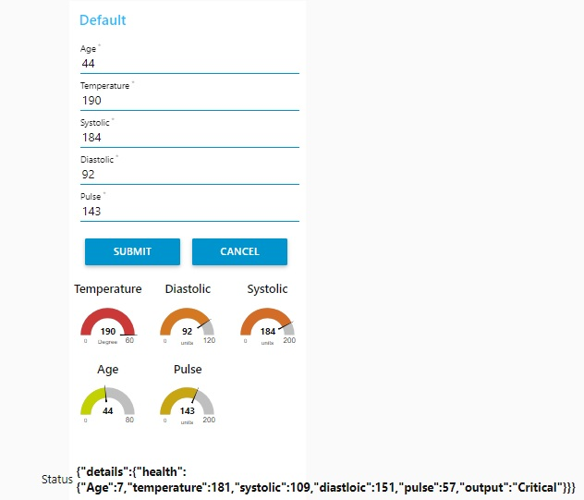
In this the sensor values are displayed in the form of gauges and the form is loaded with the values when they change in the IoT device. The above output can be viewed by the nodered url. It is given by https://node-red-ydjte-2020-10-08.eu-gb.mybluemix.net/ui.
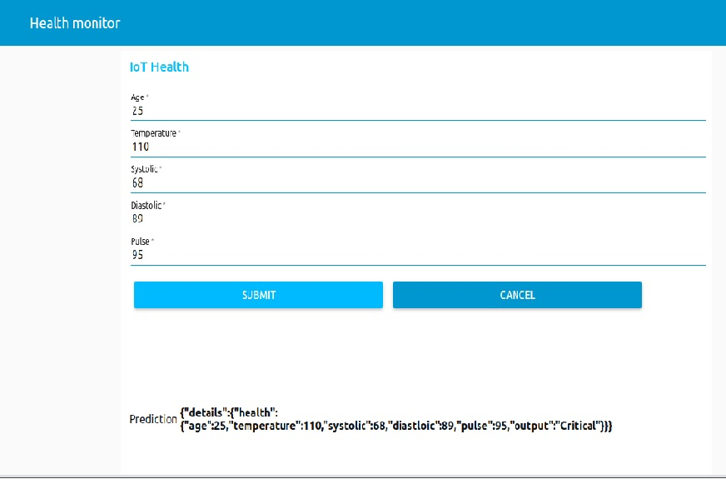
The above is the output of accepting parameters through a form and then predicting the health status of the patient. This can be viewed by the nodered url given by https://node-red-ydjte-2020-10-08.eu-gb.mybluemix.net/ui.

7. ADVANTAGES AND DISADVANTAGES
ADVANTAGES:
- Very easy and fast access to the doctor.
- Early detection of the illness.
- Very helpful when the patient cannot reach the doctor in time, this gives the prediction.
DISADVANTAGES:
- It will be available only to the people who have smart mobiles with internet.
- The patient should have minimum education to understand the predictions.

8. APPLICATIONS
1. Can be used in remote places when reaching of doctor may take time.
2. In rural areas, to predict health of a patient.
3. In regular checkups of diabetic patients.

9. CONCLUSION
It can be concluded that, this project helps many patients to know their health condition without going to a doctor. Patient’s health is predicted and some suggestions are also given to the patient. Internet of Things and Artificial Intelligence with Machine Learning is a powerful combination to yield a very good project.

10. FUTURE SCOPE
In future the project can have further extension of having more number of languages. An option of prediction language change can be inserted so that it will be reachable to all. Live remote interaction of patients with doctor can be made available.
11. BIBILIOGRAPHY
References:
- Project idea given in the project workspace.
- Videos of the GURUCOOL program.
- IBM Cloud environment and examples.

APPENDIX A:
SOURCE CODE:
- Code Snippet :
import requests
# NOTE: you must manually set API_KEY below using information retrieved from your IBM Cloud account.
API_KEY = "<your API key>"
token_response = requests.post('https://iam.ng.bluemix.net/identity/token', data={"apikey": API_KEY, "grant_type": 'urn:ibm:params:oauth:grant-type:apikey'})
mltoken = token_response.json()["access_token"]
header = {'Content-Type': 'application/json', 'Authorization': 'Bearer ' + mltoken}
# NOTE: manually define and pass the array(s) of values to be scored in the next line
payload_scoring = {"fields": [array_of_input_fields], "values": [array_of_values_to_be_scored, another_array_of_values_to_be_scored]}
response_scoring = requests.post('https://us-south.ml.cloud.ibm.com/ml/v4/deployments/e46c196d-67fd-4792-8645-6452a28efc05/predictions?version=2020-10-17', json=payload_scoring, headers={'Authorization': 'Bearer ' + mltoken})
print("Scoring response")
print(response_scoring.json())
NODERED FLOW:
[{"id":"db7593f7.8cdd5","type":"tab","label":"Collecting the health parameters from the IoT online simulator","disabled":false,"info":""},{"id":"ba600cd3.88006","type":"http request","z":"db7593f7.8cdd5","name":"","method":"POST","ret":"obj","paytoqs":"ignore","url":"https://iam.cloud.ibm.com/identity/token","tls":"","persist":false,"proxy":"","authType":"","x":390,"y":400,"wires":[["ade6829.624108","891194e.86f3868"]]},{"id":"a488e41a.fd0368","type":"function","z":"db7593f7.8cdd5","name":"Pre-tocken","func":"global.set(\"Age\",msg.payload.Age)\nglobal.set(\"Temperature\",msg.payload.Temperature)\nglobal.set(\"Systolic\",msg.payload.Systolic)\nglobal.set(\"Diastolic\",msg.payload.Diastolic)\nglobal.set(\"Pulse\",msg.payload.Pulse)\nvar apikey=\"smLOGVYz_mH1WPfky8rhJcrw25GLEy-KhDi7T-gZMnye\";\nmsg.headers={\"content-type\":\"application/x-www-form-urlencoded\"}\nmsg.payload={\"grant_type\":\"urn:ibm:params:oauth:grant-type:apikey\",\"apikey\":apikey}\nreturn msg;\n","outputs":1,"noerr":0,"initialize":"","finalize":"","x":290,"y":300,"wires":[["ba600cd3.88006"]]},{"id":"ade6829.624108","type":"function","z":"db7593f7.8cdd5","name":"Pre-Prediction","func":"var Age = global.get(\"Age\")\nvar Temperature = global.get(\"Temperature\")\nvar Systolic = global.get(\"Systolic\")\nvar Diastolic = global.get(\"Diastolic\")\nvar Pulse = global.get(\"Pulse\")\nvar token=msg.payload.access_token\nmsg.headers={'Content-Type': 'application/json',\"Authorization\":\"Bearer \"+token,\"Accept\":\"application/json\"}\nmsg.payload={\"input_data\":[{\"fields\": [[\"Age\", \"Temperature\", \"Systolic\", \"Diastolic\", \"Pulse\"]],\"values\": [[Age, Temperature, Systolic, Diastolic, Pulse]]}]}\nreturn msg;","outputs":1,"noerr":0,"initialize":"","finalize":"","x":610,"y":360,"wires":[["3aa2a8fd.951808"]]},{"id":"891194e.86f3868","type":"debug","z":"db7593f7.8cdd5","name":"","active":true,"tosidebar":true,"console":false,"tostatus":false,"complete":"payload","targetType":"msg","statusVal":"","statusType":"auto","x":620,"y":500,"wires":[]},{"id":"4c544e9c.ea296","type":"function","z":"db7593f7.8cdd5","name":"","func":"var Age = global.get ('Age')\nvar Temperature = global.get ('Temperature')\nvar Systolic = global.get ('Systolic')\nvar Diastolic = global.get ('Diastolic')\nvar Pulse = global.get ('Pulse')\nvar output=msg.payload.predictions[0].values[0][0]\nglobal.set(\"ouptut\",output)\nmsg.payload = {\n details: {\n health: {\n Age: Age,\n temperature: Temperature,\n systolic: Systolic,\n diastloic:Diastolic,\n pulse: Pulse,\n output: output\n }\n }\n}\nreturn msg;\n","outputs":1,"noerr":0,"initialize":"","finalize":"","x":730,"y":280,"wires":[["605b21e8.2dd01","878dd352.f5f69"]]},{"id":"3aa2a8fd.951808","type":"http request","z":"db7593f7.8cdd5","name":"","method":"POST","ret":"obj","paytoqs":"ignore","url":"https://us-south.ml.cloud.ibm.com/ml/v4/deployments/e46c196d-67fd-4792-8645-6452a28efc05/predictions?version=2020-09-01","tls":"","persist":false,"proxy":"","authType":"","x":780,"y":420,"wires":[["4c544e9c.ea296","1411aec6.bad5f1"]]},{"id":"1411aec6.bad5f1","type":"debug","z":"db7593f7.8cdd5","name":"","active":true,"tosidebar":true,"console":false,"tostatus":false,"complete":"payload","targetType":"msg","statusVal":"","statusType":"auto","x":950,"y":500,"wires":[]},{"id":"878dd352.f5f69","type":"debug","z":"db7593f7.8cdd5","name":"","active":true,"tosidebar":true,"console":false,"tostatus":false,"complete":"payload","targetType":"msg","statusVal":"","statusType":"auto","x":950,"y":300,"wires":[]},{"id":"605b21e8.2dd01","type":"ui_text","z":"db7593f7.8cdd5","group":"94d255a0.a337d8","order":6,"width":"16","height":"3","name":"","label":"Status","format":"{{msg.payload}}","layout":"col-center","x":930,"y":220,"wires":[]},{"id":"5a5e237b.b6e64c","type":"inject","z":"db7593f7.8cdd5","name":"","props":[{"p":"payload"},{"p":"topic","vt":"str"}],"repeat":"","crontab":"","once":false,"onceDelay":"0.1","topic":"","payload":"","payloadType":"date","x":80,"y":320,"wires":[["a488e41a.fd0368"]]},{"id":"82b8e65.54f8418","type":"ui_gauge","z":"db7593f7.8cdd5","name":"","group":"94d255a0.a337d8","order":1,"width":"3","height":"2","gtype":"gage","title":"Temperature","label":"Degree","format":"{{msg.payload.Temperature}}","min":0,"max":"60","colors":["#00b500","#e6e600","#ca3838"],"seg1":"","seg2":"","x":480,"y":100,"wires":[]},{"id":"bfd78fdb.84406","type":"ui_gauge","z":"db7593f7.8cdd5","name":"","group":"94d255a0.a337d8","order":2,"width":"3","height":"2","gtype":"gage","title":"Diastolic","label":"units","format":"{{msg.payload.Diastolic}}","min":0,"max":"120","colors":["#00b500","#e6e600","#ca3838"],"seg1":"","seg2":"","x":470,"y":200,"wires":[]},{"id":"ad19aa36.1ec708","type":"ui_gauge","z":"db7593f7.8cdd5","name":"","group":"94d255a0.a337d8","order":3,"width":"3","height":"2","gtype":"gage","title":"Systolic","label":"units","format":"{{msg.payload.Systolic}}","min":0,"max":"200","colors":["#00b500","#e6e600","#ca3838"],"seg1":"","seg2":"","x":470,"y":160,"wires":[]},{"id":"68e18af4.f66b14","type":"ui_gauge","z":"db7593f7.8cdd5","name":"","group":"94d255a0.a337d8","order":4,"width":"3","height":"2","gtype":"gage","title":"Age","label":"","format":"{{msg.payload.Age}}","min":0,"max":"80","colors":["#00b500","#e6e600","#ca3838"],"seg1":"","seg2":"","x":480,"y":60,"wires":[]},{"id":"8e05ac98.6dd7b","type":"ui_gauge","z":"db7593f7.8cdd5","name":"","group":"94d255a0.a337d8","order":5,"width":"3","height":"2","gtype":"gage","title":"Pulse","label":"units","format":"{{msg.payload.Pulse}}","min":0,"max":"200","colors":["#00b500","#e6e600","#ca3838"],"seg1":"","seg2":"","x":460,"y":260,"wires":[]},{"id":"840b64c6.5a5878","type":"ibmiot in","z":"db7593f7.8cdd5","authentication":"apiKey","apiKey":"c3016f19.8a1c","inputType":"evt","logicalInterface":"","ruleId":"","deviceId":"RSYM","applicationId":"","deviceType":"RaspberryPI","eventType":"+","commandType":"","format":"json","name":"IBM IoT","service":"registered","allDevices":true,"allApplications":"","allDeviceTypes":true,"allLogicalInterfaces":"","allEvents":true,"allCommands":"","allFormats":"","qos":0,"x":220,"y":160,"wires":[["a488e41a.fd0368","68e18af4.f66b14","82b8e65.54f8418","ad19aa36.1ec708","bfd78fdb.84406","8e05ac98.6dd7b","1e176de2.a76d42"]]},{"id":"1e176de2.a76d42","type":"ui_form","z":"db7593f7.8cdd5","name":"","label":"","group":"94d255a0.a337d8","order":1,"width":"0","height":"0","options":[{"label":"Age","value":"Age","type":"number","required":true,"rows":null},{"label":"Temperature","value":"Temperature","type":"number","required":true,"rows":null},{"label":"Systolic","value":"Systolic","type":"number","required":true,"rows":null},{"label":"Diastolic","value":"Diastolic","type":"number","required":true,"rows":null},{"label":"Pulse","value":"Pulse","type":"number","required":true,"rows":null}],"formValue":{"Age":"","Temperature":"","Systolic":"","Diastolic":"","Pulse":""},"payload":"","submit":"submit","cancel":"cancel","topic":"","x":110,"y":460,"wires":[["a488e41a.fd0368"]]},{"id":"94d255a0.a337d8","type":"ui_group","z":"","name":"IoT Health","tab":"c0792f2f.94036","order":3,"disp":true,"width":"17","collapse":false},{"id":"c3016f19.8a1c","type":"ibmiot","z":"","name":"","keepalive":"60","serverName":"fgc20h.messaging.internetofthings.ibmcloud.com","cleansession":true,"appId":"","shared":false},{"id":"c0792f2f.94036","type":"ui_tab","z":"","name":"Health monitor","icon":"dashboard","disabled":false,"hidden":false}]

